**Information Retrieval and web search Assignment**

Related files:

HResult.csv LiveResult.csv

**Programming language**: you can use any language you want

# Program requirements:

You are required to write an application/program or script that will generate a fused results set from a set of historic results using the Probfuse fusion method

* 1. Ask the user for a set of historical results in csv format where each result set Starts with the IR engine Letter and the Query Number. So A2, means this is from IR engine A and is the second query . see below.
  2. Ask the user for input : how many segments to use
  3. Ask the user for the name of the live results file. In CSV format with each IR engine identified as the first entry (see below)
  4. Ask the user to state what results they want fused out of A, B, C or D
  5. Output the fused set of results to a file (user should not be asked for an output file name

# Historical data file

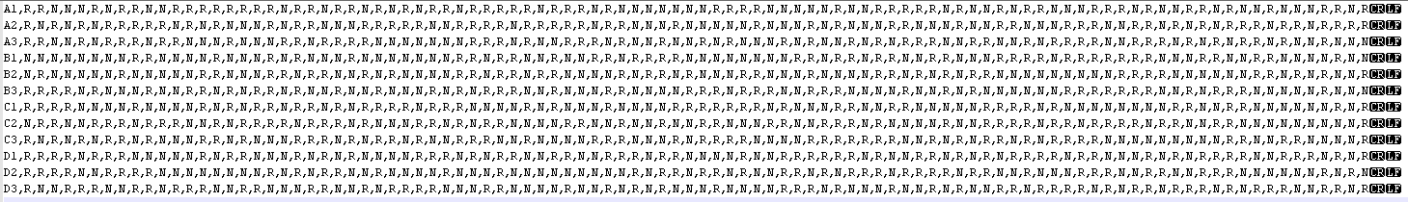

Each line is a new result set

Each line starts with the name of the IR engine (A, B , C or D) and the number of the query (1, 2, 3) and is separated from the result set by a comma (,)

Each result set contains R for a relevant result and N for a non-relevant result. There are no unknown results, this is a FULLY JUDGED CORPUS.

Each result is separated from the next by a comma (,)

Each line ends in a CR and a LF character to indicate end of line

# Live Results file:

The live results file is a CSV file

Each line contains one set of live results

Each line starts with the IR Engine name (A. B , C or D) , the name is separated for the result set by a comma (,)

The result set consists of a set of document numbers (integer values only) separated by a comma (,) Each line ends with a CR and a LF character to indicate the end of a line

# Operation:

All input and output files should be assumed to be in the same directory as your application, program or script.

All output should be to a file(s) in the same directory as your program or script.

You are NOT expected to create a GUI. Command line input is preferred either during the application run or as starting parameters

# Application Code:

you must submit your application code in a format that can be read.

Your code must be commented with useful comments – eg

//this prints the result to the screen

This is NOT a useful comment. It states exactly what the application is doing

//this function takes the file name as input and assigns it to a variable which is used to open the file and is used again later in the calculation function to read in the options selected by the user. The filename does not require an extension to be added as this is handled by the library (x) imported above. If there is more than one file with the same name, this function will select the first one listed in the directory.//

This is a useful comment as it explains how the block of code it relates to functions within the overall application and informs the reader about how it works and what the exceptions or possible problems could be when it is used.

You do NOT need to comment every line. You only need to comment a block that is important to how your application/script runs.